Chapter 18, Solution 59.

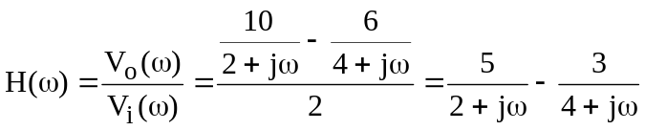

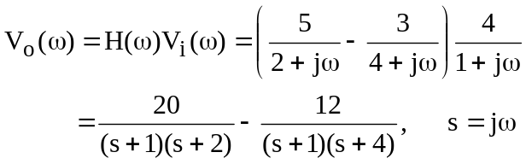

Using partial fraction,

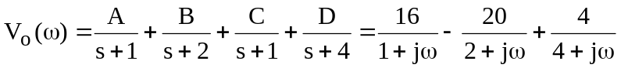

Thus,

